Richard Compton

Zachary Denny

Samuel Khalil

# CSI 3450 - Database Project - Phase 1

## **Problem Statement**

The application we will be constructing will serve as a resource for students or professors of, and visitors to university campuses in Michigan to discover the most interesting, provoking, or action-packed locations on a specific campus. One database or more must be constructed to:

1. Store various universities’ information, such as their names, addresses, population, mascot, et cetera.
2. Hold names, addresses, descriptions, and pictures of specific locations on a school’s campus.
3. Store user information (name, age, occupation, a reason for accessing database, et cetera).

Without a database, this application would be cluttered, difficult-to-navigate, and, most likely, slow. Thus, at least one database is necessary.

## **System Requirements**

The application will be accessible on the Apple App Store, free, and downloadable to users of Apple products. Users will then be able to open the application on their phones and utilize all of its various features. The following features will be available:

1. The application shall allow users to find interesting locations on a university campus.
2. The application shall use GPS technology.
3. The application shall allow universities to control their own accounts.
4. The application shall have an administrator that approves all locations added to the database.

The application will not serve as a substitute for applications like Google Maps and Apple Maps, as it will not show users how to navigate to certain locations. Instead, it will simply advertise and make students/professors/visitors aware that these locations exist.

## **Conceptual Database Design**

This is the ER Diagram for the application:

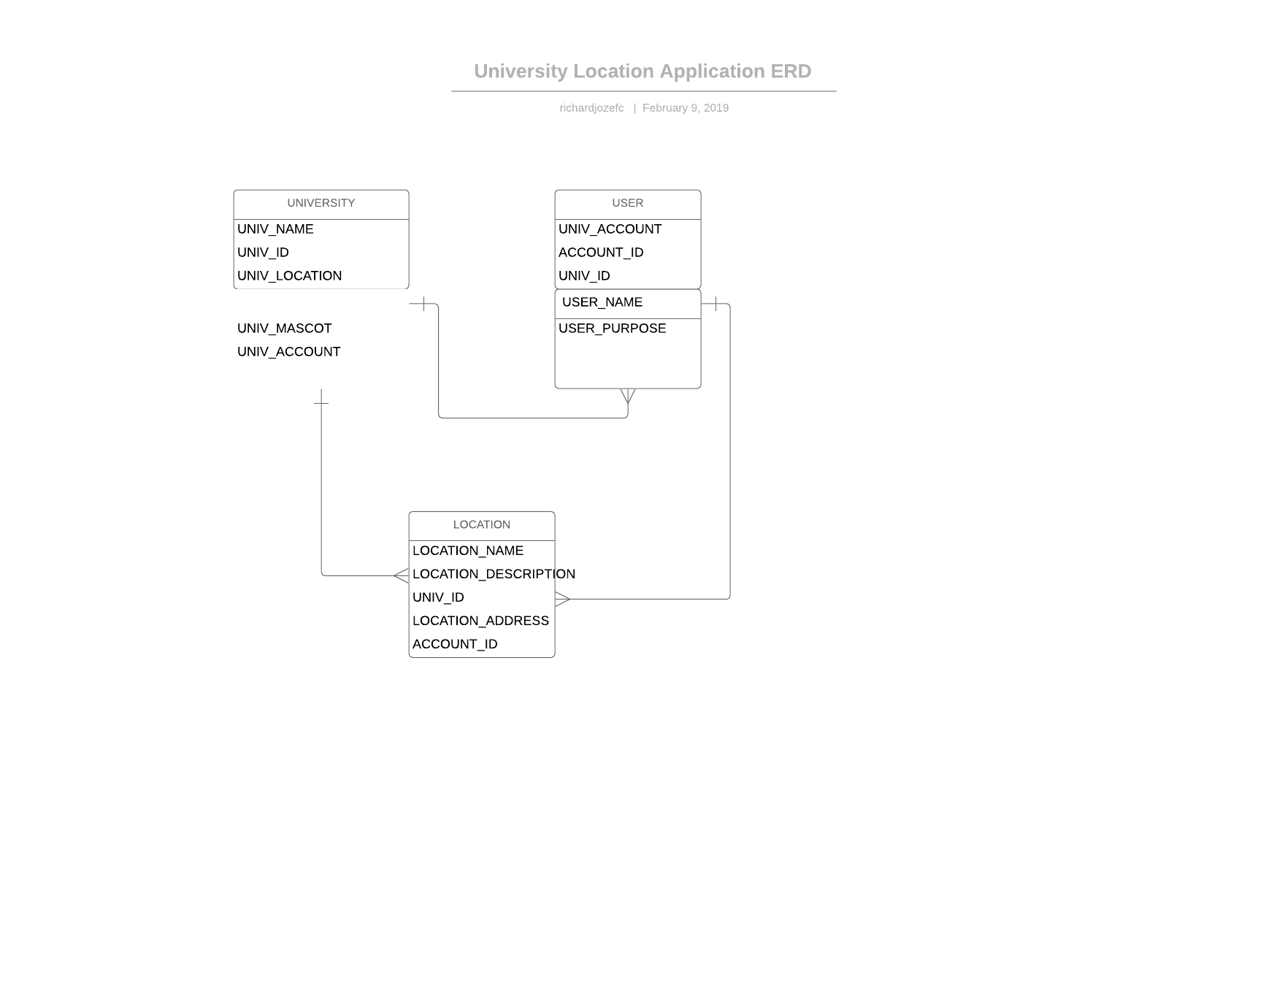

## **Functional Requirements**

The application will frequently interact between the different entities. Many retrievals and updates will be made, entities will be accessed, and modifications will be made. Here are a few example database transactions:

* Users will enter information about universities and locations, updating the database.
* Users will submit LOCATION_DESCRIPTION, requiring a decision to be made about updating or not updating the description.
* To locate specific locations, their UNIV_ID will be used.
* Specific users will be connected to specific universities using a UNIV_ID.
* Everytime a user logs in to the application, all of the databases will be accessed. The user entity will be required for login and the university and location entities will be required to populate the application’s data.

## **Estimate of Effort**

The expected effort in terms of person-weeks is six weeks. Two weeks to create the application requirements document, two weeks to create the infrastructure of the application and its database, and two weeks to implement the database and finalize the entire application.